- News
- Sports
- Opinion
- Obituaries
- Politics
- Arts & Life
- More...

Opinion: Introducing Ordinary Barbie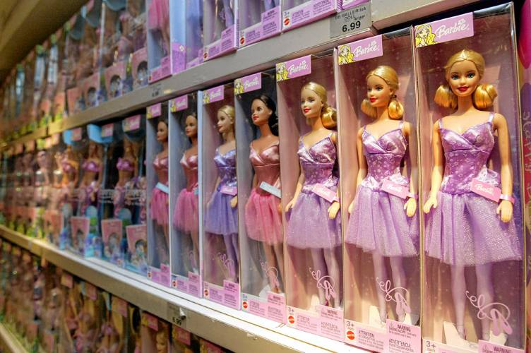
A line of Barbie dolls sit on the shelf in 2004 at Toys ‘R Us Times Square flagship store in New York. Kathy Willens / AP

By STEPHANIE RUTT
Published: 9/6/2023 6:00:02 AM
Rev. Dr. Stephanie Rutt is founding minister of the Tree of Life Interfaith Temple in Amherst. She lives in Nashua. To read more of her writing visit becomeaforceforgood.com.
Who’d of thought a doll could cause such a fuss? Barbie, the movie, reveals for some the true existential crisis in the feminine experience while to others, shadows demonic messages capable of transmuting all Godliness into evil. One can only wonder how 11½ inches of hard vinyl can cause an entire universe to turn pink, with blushing delight or raging anger.
This quintessential feminine beauty made her debut in 1959. White, blond, shaped to perfection in just the right places, flawless in every way — so, of course, always smiling. After starting out as a teen fashion model, she went on to have a host of careers: astronaut, Air Force pilot, Major League Baseball player, presidential candidate, even a rapper, among others. Yes, apparently this quintessential beauty was fully capable of being anything she wanted to be. Oh, and let’s not forget, she also had the quintessential boyfriend, Ken, who of course was handsome as ever and fully content to be her, yes, always smiling sidekick.
And so it was that in Barbie Land all the women were Barbies, beautiful, powerful, and in charge of their destinies, and all the men were Kens, supportive, and constantly vying for attention. Perfect. Pink. Sweet as cotton candy.
I know many people, particularly women, will recognize the ironic juxtaposition here.
I did. For, in the movie, even as Barbie leaves Barbie Land for the real world to get help for her unbearable existential crisis (flat feet, Ah!) and then discovers Ken stowed in the backseat — well, I knew exactly where this was heading. And, in spite of reminding myself, “She’s only a doll!” it still made my insides churn. “I don’t want to see her lose power — even if she is pink!”
But, true to expectation, in the real world, Barbie finds herself out of place, her wily ways suddenly invisible, attracting stereotypical sexist reactions wherever she goes. Ken, of course, finds his mojo, complete with mob-towering shoulders, helped by a white furry coat, and a dismissive deal-with-you-later look. He’s in charge now.
And just like that, I felt the flip sides of matriarchy and patriarchy, each the same coin. And, for me, one of the movie’s great takeaways: in gender hierarchies, one group is always losing.
This led me to another great takeaway: the passing suggestion to introduce an ‘Ordinary Barbie.’ This Ordinary Barbie would have more realistic qualities, yet presumably still be able to pursue her dreams without the weight of pink perfection. This felt to me reachable, attainable, even possible for every little girl, or boy, for surely there’d also be an ‘Ordinary Ken.’
As a Boomer, I was a young girl when Barbie made her iconic entrance. I remember her smiling from inside the cellophane-covered pink box. I was beyond the doll-playing stage so never wanted a Barbie but, really, never would have. She just looked too different from me, perfect, like one of those in-crowd girls in school, and lived out fantasies I’d never imagined. I didn’t feel it’d be cool to be her or not be her. She just wasn’t anywhere in my world.
But an Ordinary Barbie? Now, that may have lit a spark. One that looked like most girls and gave off a vibe of ‘regardless of what you look like, you too could find some kind of beauty and awesomeness. maybe just by being yourself?’ Ah! Imagine that!
And perhaps such a doll could help unravel all those contradictory messages voiced by real-world Gloria, part of the mother-daughter duo who returns to Barbie Land with Barbie. Arguably, the most potent scene in the movie, she exclaims, “It’s literally impossible to be a woman. You have to never get old, never be rude, never show off, never be selfish, never fall down, never fail, never show fear, never get out of line. It’s too hard! It’s too contradictory and nobody gives you a medal or says thank you!”
But wait. It seems Barbie might just share the same sentiment. In the end, she leaves Barbie Land to go to the real world because she just doesn’t feel like Barbie anymore and wants to know about being real.
Can we dare to think iconic Barbie could actually become Ordinary Barbie? Could we imagine her feeling the full emotions and contradictions of being human, the messiness, inexplicable joy, raw rage? Better still, could we imagine each little girl discovering, through her Ordinary Barbie, that all such feelings come and go but she, long after her Ordinary Barbie is put away, remains her beautiful, awesome self?
It’s a thought. After all, in the movie, it was decided Ordinary Barbie could actually make money.
Ah, but just maybe she could make something much more important. Dreams, real dreams, for real girls in the real world, all as they each munch on their own pink (of course) cotton candy.

